1. Two creatures (participants) in the market bull and bear .
2. Bull attacks prey by pushing up whereas bear by pushing down.
3. Bull in market tries to take prices up whereas bear to take down. This battle is constant.
4. This battle or **price action** is represented by Japanese Candlesticks.
5. **Terms**: Instead of Buy/Sell, use Long/Short Position.
6. **There are 5 sentiments based on 2 kinds of participants (Bull, Bear)**
7. 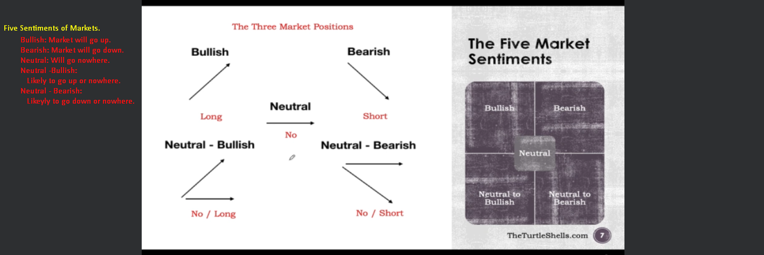
8. **Just Info**: We can make profits no matter where market is going (even when market is going no where like in option trading).